ASSESSMENT TOOL 2

COURSE NAME: MOBILE COMPUTING
COURSE CODE: ITA03

COURSE OUTCOME COVERED

CO2: Compare mobile communication technologies, including multiple access techniques and network evolution, based on performance and applications. (BL-1, BL-2, BL-3)

QUESTIONS: 5 Total Marks: 100

Annexure A

EXPERIMENTATION

Code of Conduct:

I ANIKSHA EVANJALIN M(192521308) (Name / Reg No) certify that this submission is my original work and that I have adhered to the guidelines specified for this assessment.

I understand that any violation of academic integrity rules will result in disciplinary action.

Signature of the student:
ANIKSHA EVANJALIN M

Annexure A - QUESTIONS

Figma-Based Mobile IP Communication Workflow Analysis (BL4 – Analyze)
Design an interactive Figma prototype illustrating the complete workflow of Mobile IP communication when a Mobile Node moves from its Home Network to a Foreign Network. Your design should include the Home Agent (HA), Foreign Agent (FA), Correspondent Node (CN), Care-of Address (CoA), Registration Process, and Packet Tunneling.
Analyze the communication process by identifying:
- The purpose of each network component.
- Points where packet delay or packet loss may occur.
- The effect of node mobility on communication performance.
- Possible improvements to reduce latency.
Deliverables:
- Figma (.fig) design
- GitHub repository containing exported images/PDF and documentation (README).

Comparative Network Architecture Design Using Figma (BL4 – Analyze)
Using Figma or draw.io, create a comparative architectural diagram showing both a Cellular Wireless Network and a Mobile Ad Hoc Network (MANET) operating in the same smart city environment.
Analyze the architectures by comparing:
- Infrastructure dependency.
- Routing mechanisms.
- Scalability.
- Fault tolerance.
- Mobility support.
- Suitable application scenarios.
Highlight the advantages and limitations of each architecture through annotations in your design.
Deliverables:
- Editable design file.
- GitHub repository with screenshots, comparison report, and design assets.

Routing Protocol Visualization and Analysis (BL4 – Analyze)
Develop an interactive visualization using Figma, Mermaid.js, D3.js, or any visualization framework illustrating the operation of one Proactive Routing Protocol and one Reactive Routing Protocol in a mobile wireless network.
Analyze:
- Route discovery process.
- Route maintenance mechanism.
- Routing overhead.
- Delay in establishing communication.
- Performance under high node mobility.
Include a comparative summary explaining which protocol performs better under different mobility conditions.
Deliverables:
- Source code/design files.
- GitHub repository with implementation, screenshots, and analysis report.

Mobile IP Application Design for Smart Healthcare (BL4 – Analyze)
Design a Smart Healthcare Mobile IP system using Figma that enables doctors, ambulances, hospitals, and patients to remain connected while moving across different wireless networks.
Analyze:
- How Mobile IP maintains uninterrupted communication.
- Challenges during handoff between networks.
- Security vulnerabilities during mobility.
- Possible design improvements to increase reliability.
Provide navigation between screens demonstrating different mobility scenarios.
Deliverables:
- Interactive prototype.
- GitHub repository containing design files, exported prototype, and documentation.

Wireless Network Decision Dashboard Using GitHub Project (BL4 – Analyze)
Create a web-based dashboard (using HTML/CSS/JavaScript, React, or another programming framework) or an interactive Figma dashboard that helps network engineers determine whether a given scenario should use Mobile IP, Cellular Networks, or Ad Hoc Networks.
The dashboard should analyze multiple parameters such as:
- Node mobility.
- Infrastructure availability.
- Network size.
- Routing complexity.
- Energy consumption.
- Reliability requirements.
The system should justify its recommendation based on the analyzed parameters.
Deliverables:
- Source code or Figma project.
- GitHub repository with complete code/design, README, screenshots, and analysis report.

ANSWER

EXPERIMENT 1: Figma-Based Mobile IP Communication Workflow Analysis
Aim:
To design an interactive Figma prototype illustrating Mobile IP communication when a Mobile Node moves from its Home Network to a Foreign Network, including Home Agent, Foreign Agent, Correspondent Node, Care-of Address, registration and packet tunneling.
Procedure:
- Open Figma.
- Create a new design file.
- Create a frame for the Mobile IP communication workflow.
- Add the Mobile Node, Home Agent, Foreign Agent and Correspondent Node.
- Show the movement of the Mobile Node from the Home Network to the Foreign Network.
- Add the Care-of Address and registration process.
- Connect the network components using arrows.
- Illustrate packet tunneling from the Home Agent to the Foreign Agent.
- Add annotations explaining packet delay, packet loss and mobility.
- Highlight possible improvements to reduce communication latency.
- Make the prototype interactive using links and buttons.
- Review, save and export the design.
- Upload the exported images and documentation to GitHub.

Design:
- Create a Mobile IP communication workflow containing the following components:
- Mobile Node (MN): Device that moves between different networks.
- Home Agent (HA): Maintains the Mobile Node's home address and forwards packets.
- Foreign Agent (FA): Provides connectivity to the Mobile Node in the foreign network.
- Correspondent Node (CN): Device communicating with the Mobile Node.
- Care-of Address (CoA): Temporary address representing the Mobile Node's current location.
- Registration: Registers the Care-of Address with the Home Agent.
- Packet Tunneling: Transfers packets from the Home Agent to the Foreign Agent.
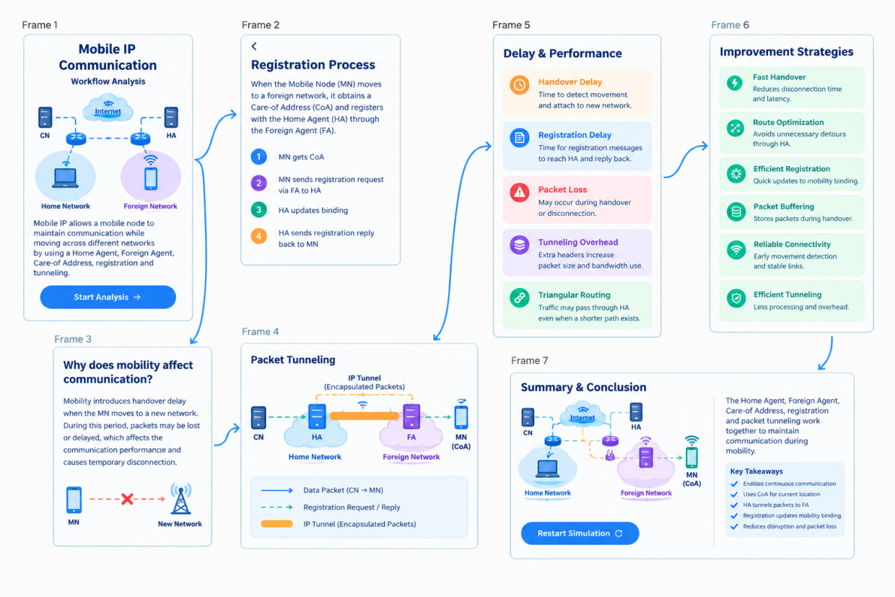
Result:
Thus, an interactive Figma prototype illustrating the Mobile IP communication workflow was designed successfully. The movement, registration and packet tunneling processes were represented, and communication delays and possible improvements were analysed.

EXPERIMENT 2: Comparative Network Architecture Design Using Figma
Aim:
To design and compare Cellular Wireless Network and Mobile Ad Hoc Network (MANET) architectures using Figma or draw.io and analyse their infrastructure, routing, scalability, fault tolerance and mobility support.
Procedure:
- Open Figma or draw.io.
- Create a new design file.
- Create two separate frames for Cellular Wireless Network and MANET.
- Add mobile devices, base stations and network components.
- Connect the components using lines and arrows.
- Illustrate communication through base stations in the Cellular Network.
- Illustrate direct communication between nodes in MANET.
- Add annotations explaining the working of both architectures.
- Compare infrastructure dependency, routing and scalability.
- Highlight the advantages and limitations of both networks.
- Review and edit the diagrams.
- Save and export the design.
- Upload the design, screenshots and comparison report to GitHub.
Design:
Create two network architecture diagrams side by side.
1. Cellular Wireless Network
- Uses base stations.
- Requires fixed infrastructure.
- Centralized network management.
- Suitable for mobile communication.
2. Mobile Ad Hoc Network (MANET)
- Does not require fixed infrastructure.
- Nodes communicate directly or through other nodes.
- Uses dynamic routing.
- Suitable for temporary networks.
Comparison Table:
Parameters | Cellular Network | MANET
Infrastructure | Required | Not required
Routing | Through network infrastructure | Node-based routing
Scalability | High with infrastructure support | Depends on network conditions
Fault Tolerance | Depends on network infrastructure | Alternative node paths may be used
Mobility | Supported through handoff | Supported through dynamic routing
Applications | Mobile phones, 4G, 5G | Military, disaster recovery
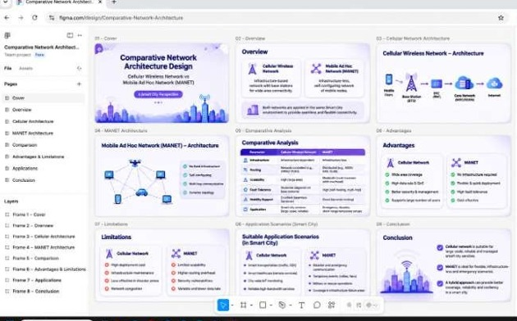

Result:
Thus, Cellular Wireless Network and MANET architectures were designed and compared successfully. Their working principles, advantages, limitations and suitable application scenarios were analysed.

EXPERIMENT 3: Routing Protocol Visualization and Analysis
Aim:
To develop an interactive visualization of one Proactive Routing Protocol and one Reactive Routing Protocol in a mobile wireless network and analyse their route discovery, route maintenance, routing overhead and performance under node mobility.
Procedure:
- Open Figma or a suitable visualization tool.
- Create a new design or project.
- Select one Proactive Routing Protocol (DSDV).
- Select one Reactive Routing Protocol (AODV).
- Create network nodes and connect them using links.
- Illustrate route discovery in the AODV protocol.
- Illustrate routing table maintenance in the DSDV protocol.
- Show how routes are updated when nodes move.
- Add annotations explaining routing overhead and communication delay.
- Compare the performance of both protocols under different mobility conditions.
- Add interactive elements to demonstrate routing operations.
- Review and save the design.
- Upload source files, screenshots and analysis reports to GitHub.

Design:
Create two routing protocol diagrams.
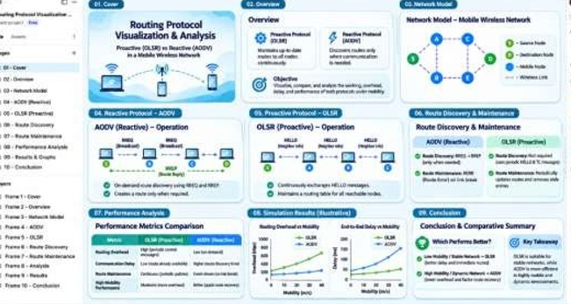
1. Proactive Routing – DSDV
- Maintains routing tables.
- Routes are available before sending data.
- Periodically updates routing information.
- Has higher routing overhead.
2. Reactive Routing – AODV
- Discovers routes when needed.
- Uses Route Request (RREQ).
- Uses Route Reply (RREP).
- Reduces unnecessary routing overhead.

Comparison Table:
Parameters | DSDV | AODV
Type | Proactive | Reactive
Route Discovery | Before communication | When required
Route Maintenance | Routing table updates | Route error messages
Routing Overhead | Higher | Generally lower
Initial Delay | Low | Higher due to route discovery
High Mobility | Frequent table updates | Frequent route discoveries
Result:
Thus, the DSDV and AODV routing protocols were visualized and compared successfully. Their route discovery, route maintenance, routing overhead and performance under different mobility conditions were analysed.

EXPERIMENT 4: Mobile IP Application Design for Smart Healthcare
Aim:
To design a Smart Healthcare Mobile IP application using Figma that enables doctors, ambulances, hospitals and patients to communicate continuously while moving between different wireless networks.
Procedure:
- Open Figma.
- Create a new mobile application design file.
- Design the login and home screens.
- Create separate screens for doctors, patients, ambulances and hospitals.
- Add Mobile IP network components such as Home Agent and Foreign Agent.
- Illustrate communication when an ambulance moves between wireless networks.
- Show the registration and handoff process.
- Add patient information and emergency communication screens.
- Include security features to protect patient information.
- Connect the screens using buttons and interactive navigation.
- Review and test the prototype.
- Save and export the design.
- Upload the prototype and documentation to GitHub.
Design:
Create an interactive Smart Healthcare mobile application with the following screens.
Main Screens:
- Login Screen: Allows doctors, patients and hospital staff to log in.
- Patient Screen: Displays patient details and medical information.
- Doctor Screen: Allows doctors to access patient information.
- Ambulance Tracking Screen: Displays the ambulance's current location.
- Hospital Screen: Displays hospital availability and emergency details.
- Network Handoff Screen: Demonstrates communication when devices move between networks.
Mobile IP Features:
- Maintains communication during network movement.
- Uses Home Agent and Foreign Agent.
- Supports registration and handoff.
- Protects patient data using authentication and encryption.
- Reduces communication interruptions during emergencies.
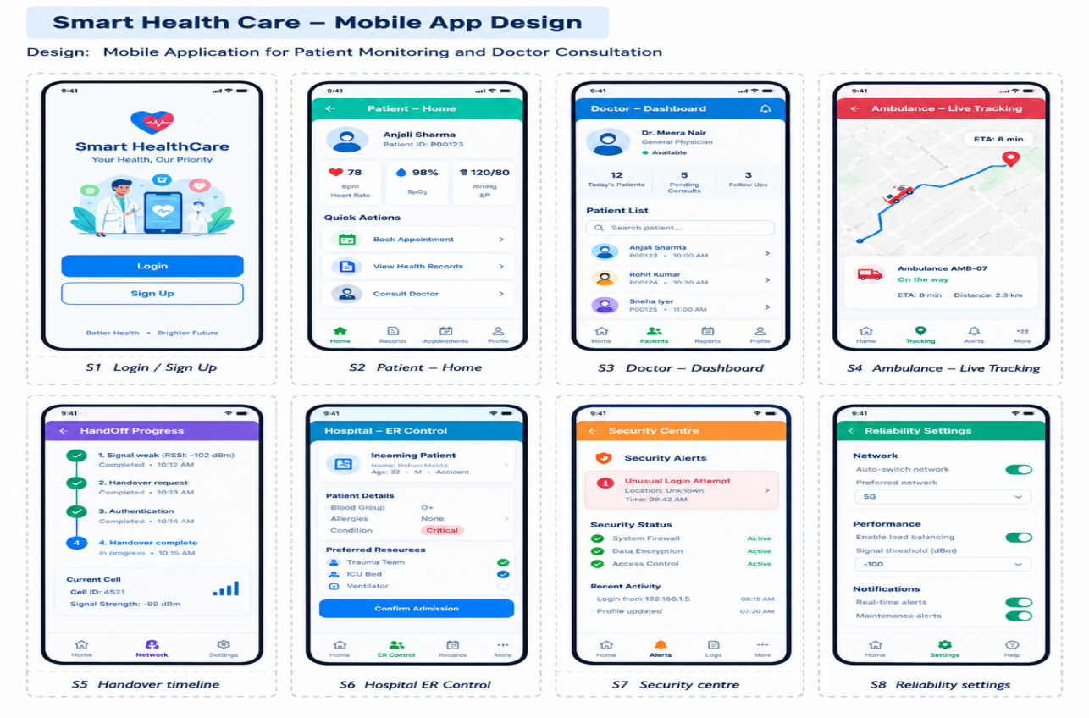
Result:
Thus, an interactive Smart Healthcare Mobile IP application prototype was designed successfully. Communication between doctors, ambulances, hospitals and patients was demonstrated, and mobility challenges, security issues and reliability improvements were analysed.

EXPERIMENT 5: Wireless Network Decision Dashboard Using GitHub Project
Aim:
To develop an interactive Wireless Network Decision Dashboard that helps network engineers select a suitable network technology (Mobile IP, Cellular Network or Ad Hoc Network) based on mobility, infrastructure availability, network size, routing complexity, energy consumption and reliability requirements.
Procedure:
- Open Visual Studio Code or an online code editor.
- Create a new project folder.
- Create HTML, CSS and JavaScript files.
- Design a dashboard interface.
- Add input fields for network mobility and infrastructure availability.
- Include network size, routing complexity and energy consumption parameters.
- Add reliability requirements as an input.
- Implement JavaScript logic to analyse the given parameters.
- Display a suitable network recommendation based on the inputs.
- Show the reason for selecting the recommended network.
- Test the dashboard with different network scenarios.
- Save the project and upload the source code to GitHub.
- Add screenshots and project documentation in the README file.
Design:
Create a web-based Wireless Network Decision Dashboard.
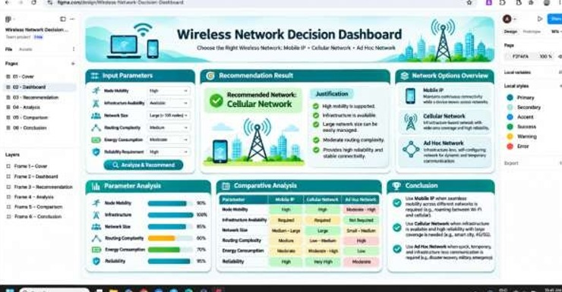

Dashboard Components:
1. Input Section:
Node Mobility
Infrastructure Availability
Network Size
Routing Complexity
Energy Consumption
Reliability Requirements
2. Network Selection Section:
Mobile IP
Cellular Network
Ad Hoc Network
3. Recommendation Section:
Displays the selected network and the reason for choosing it.
Example Decision Table:
Network Scenario | Recommended Network
High mobility with continuous communication | Mobile IP
Large network with available infrastructure | Cellular Network
No fixed infrastructure | Ad Hoc Network
Temporary emergency communication | Ad Hoc Network

Result:
Thus, an interactive Wireless Network Decision Dashboard was developed successfully. It analysed the given network parameters and provided suitable network recommendations with explanations based on the selected scenario.

RUBRICS FOR CALCULATION:

Criteria | Weightage | Level 4 – Exemplary | Level 3 – Proficient | Level 2 – Developing | Level 1 – Beginning
Understanding of Experiment | 20% | Clearly understands the objective, procedure, and concepts | Good understanding with minor gaps | Basic understanding of the experiment | Limited understanding of the experiment
Experimental Procedure | 25% | Follows the procedure correctly and systematically | Follows the procedure with minor errors | Follows the basic procedure with some errors | Unable to follow the procedure correctly
Application of Concepts | 20% | Applies concepts accurately during experimentation | Applies relevant concepts with minor errors | Applies basic concepts with limited accuracy | Unable to apply appropriate concepts
Results & Analysis | 25% | Obtains accurate results and provides clear analysis | Results are mostly accurate with minor errors | Results are partially correct with limited analysis | Results are incorrect or analysis is missing
Documentation & Presentation | 10% | Records observations clearly and presents the experiment systematically | Documentation is clear with minor issues | Documentation is incomplete or unclear | Poorly documented and presented

